CASE STUDY: QUESTIONS AND ANSWERS

This dataset has funding information of the Indian startups from January 2015 to August 2017.

**Feature Details:**

**SNo** – Serial number.

**StartupName** – Name of the startup which got funded.

**IndustryVertical** – Industry to which the startup belongs.

**SubVertical** – Sub-category of the industry type.

**CityLocation** – City which the startup is based out of.

**InvestorsName** – Name of the investors involved in the funding round.

**AmountInUSD** – Funding Amount in USD.

**Remarks** – Other information, if any.

**Question 1:**

1. Find out what type of startups are getting funded in the last few years?
2. Who are the important investors?

**Answer:**

These are the top 10 categories of startups that are getting funded these days.

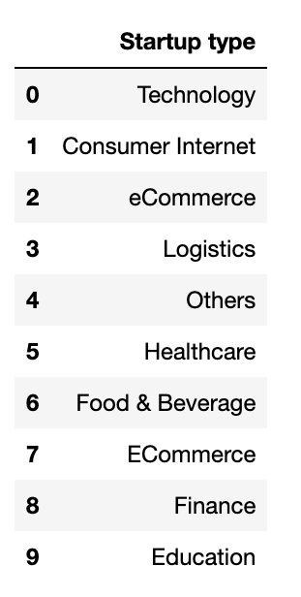

These are the top 20 investors with the total number of investments.

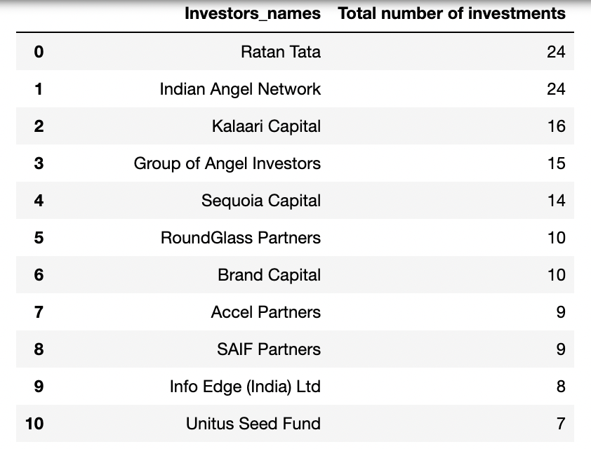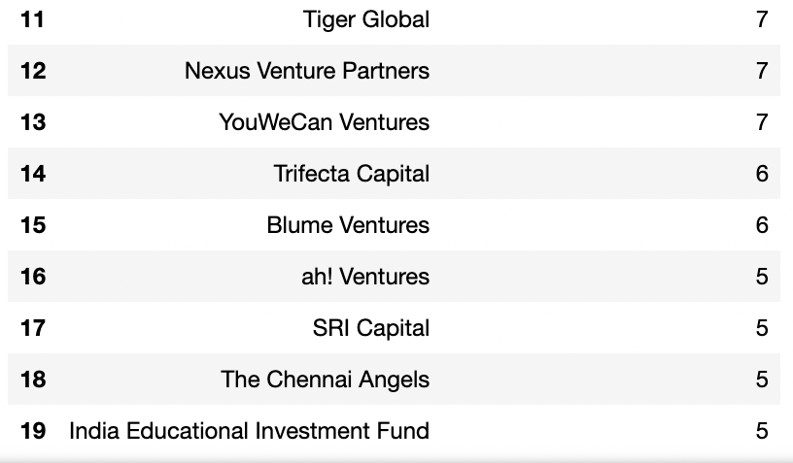

**Question 2:**

Check the trend of investments over the years. To check the trend, find -

* Total number of fundings done in each year, in ascending order.
* Plot a line graph between year and number of fundings. Take year on x-axis and number of fundings on y-axis.

Note: There is some error in the ‘Date’ feature. Make sure to handle that.

**Answer:**

Total number of fundings done in each year is shown below in the table.

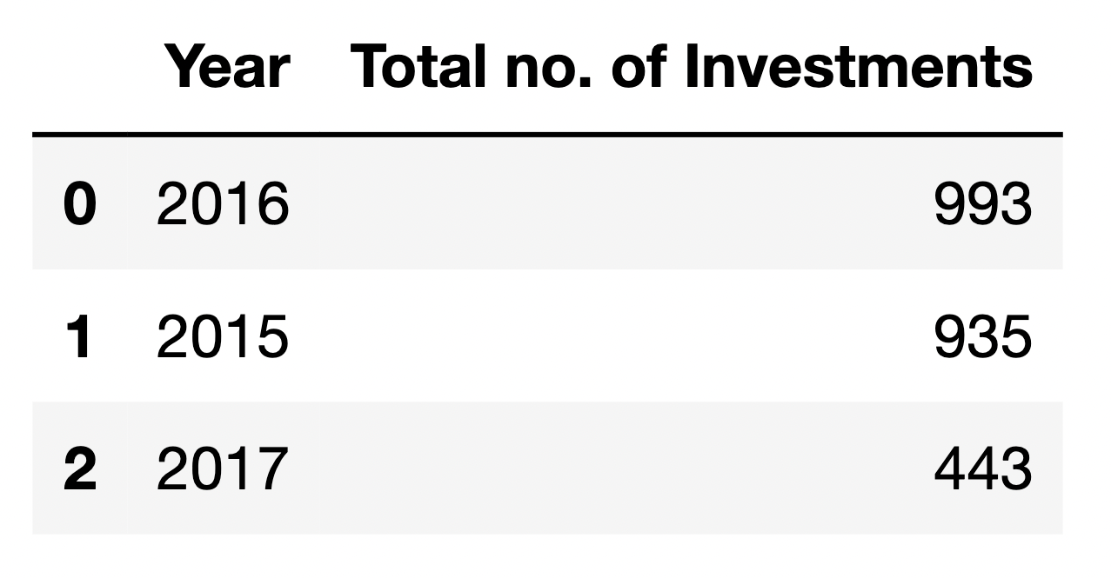

Line graph between year and number of fundings done in each year.

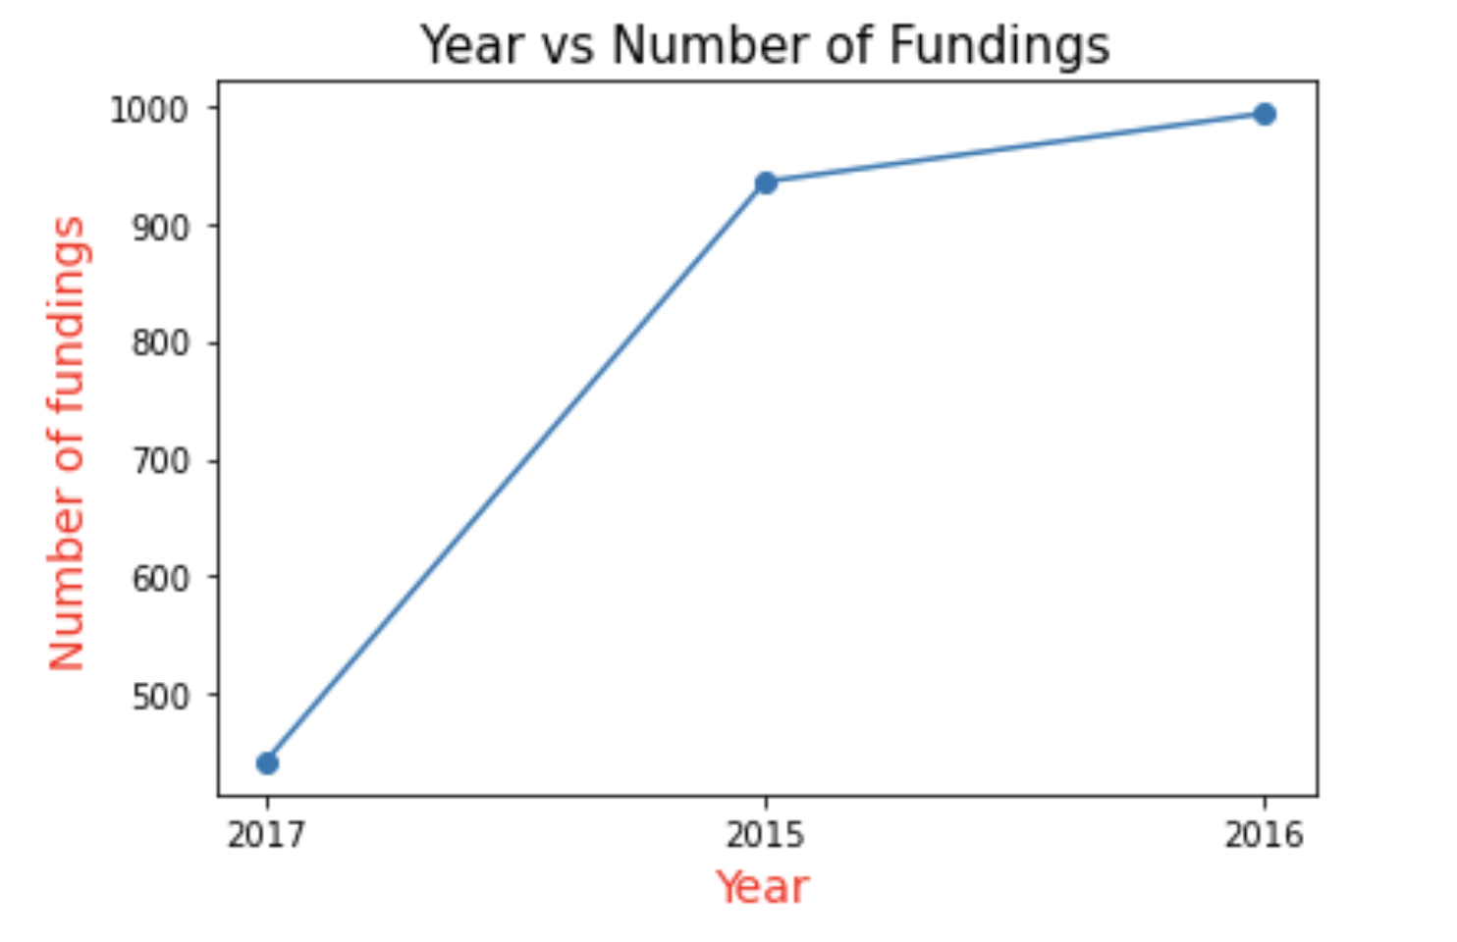

**Question 3:**

* Find out which cities are generally chosen for starting a startup.
* Find top 10 Indian cities which have most number of startups.
* Plot a pie chart and visualise it.
* Print the city and number of startups in that city also.

**Answer:**

Pie chart for top 10 Indian cities which have the greatest number of startups.

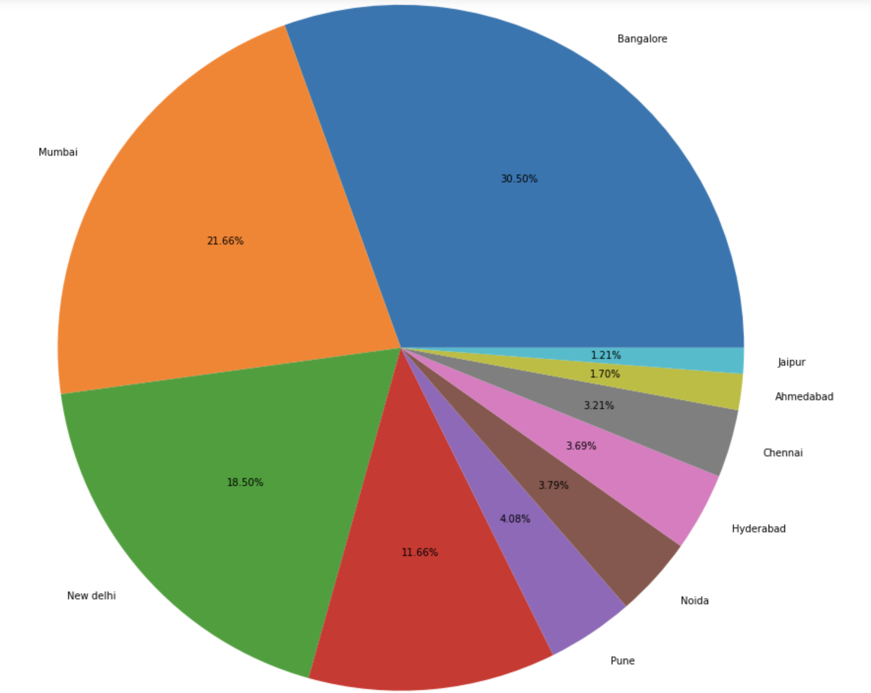

It can be seen for the pie chart that Bangalore in the city which has the highest number of startups. Then, Mumbai followed by New Delhi and many other cities.

Among these 10 cities, 30.50 % startups are situated in Bangalore. Jaipur has the smallest number of startups among these 10 cities.

The table shows the number of startups in each city, arranged in ascending order by the total number of startups.

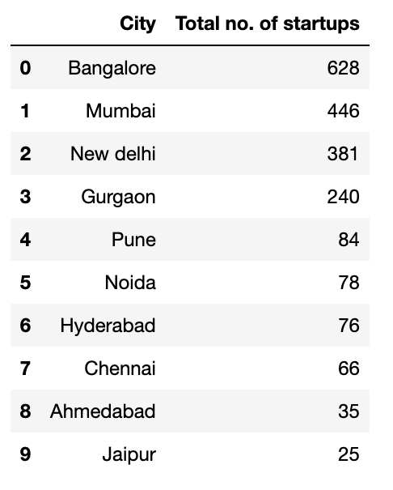

**Question 4:**

Find the top 5 startups who received the greatest number of funding rounds. The startups which got fundings maximum number of times.

Print the startup name in descending order with respect to the number of funding round as integer value.

**Answer:**

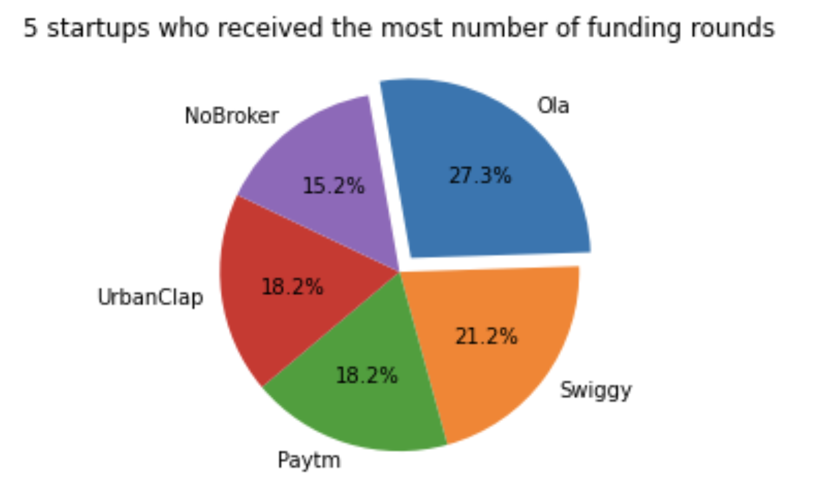

It can be seen for the above pie chart that Ola is the startup who received the greatest number of fundings round during the given period.

Ola received 27.3% of the funding rounds among the above 5 startups, followed by NoBroker.

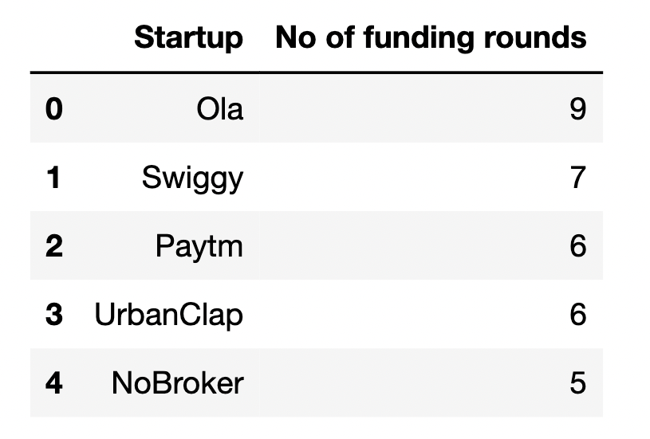

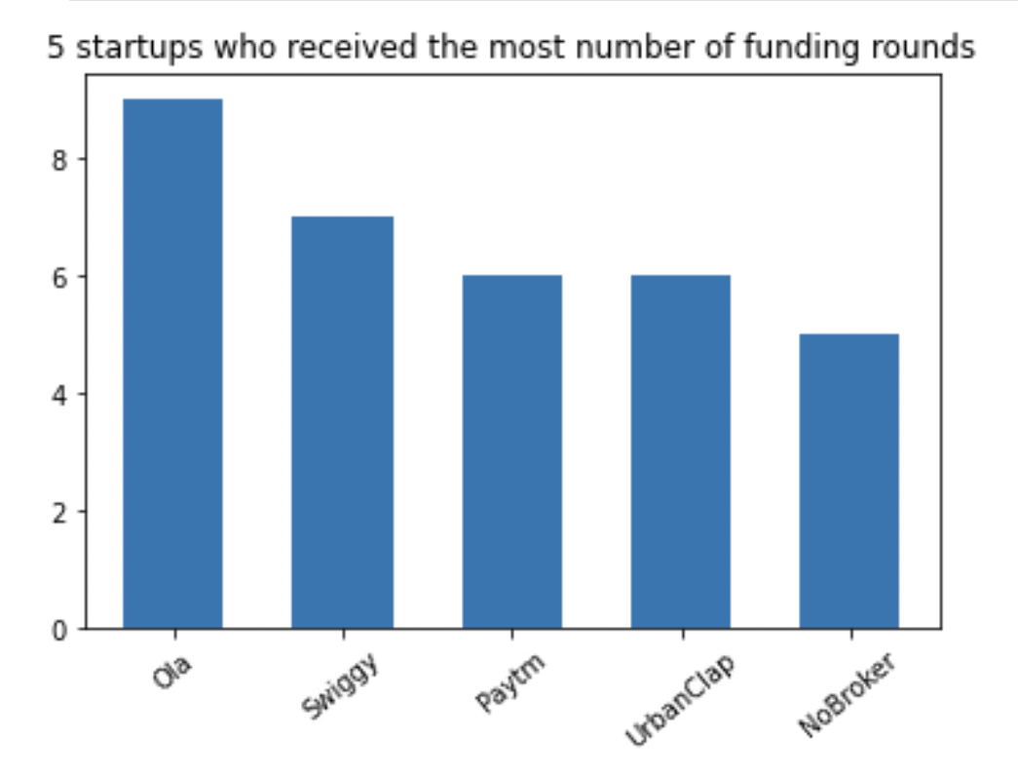

The table and the bar graph show the no. Of funding rounds for the top 5 startups.

It can be seen that Ola has total 9 funding rounds, which is the maximum among the 5 startups.